The Sullivan Centre

Provider Access Policy

1 | Summary | Provider Access Policy
2 | Responsible person | Katie Troake
3 | Accountable SLT member | Katie Troake
4 | Applies to | ☒All staff  ☒Support staff  ☒Teaching staff
5 | Who has overseen development of this policy | Katie Troake
6 | Who has been consulted and recommended policy for approval | Governing Body
7 | Approved by and date | Governing Body 28.11.24
8 | Version number | 2
9 | Available on | Trust website  Academy website  SharePoint | ☐Y ☒N  ☒Y ☐N  ☒Y ☐N
10 | Related documents (if applicable)
11 | Disseminated to | ☒Trustees/governors  ☒All staff  ☒Support staff  ☒Teaching staff
12 | Date of implementation (when shared) | 28.11.24
13 | Consulted with recognised trade unions | ☐Y ☐N

Contents
1. Introduction 4
2. Pupil Entitlement 4
3. Destinations of pupils 4
4. Management of Provider Access Requests 4
5. Opportunities for access 4
6. Premises and Facilities 4

Introduction

This policy statement sets out the school’s arrangements for managing the access of providers to pupils at the school for the purpose of giving them information about the provider’s education or training offer. This complies with the school’s legal obligations under Section 42B of the Education Act 1997.

- Pupil entitlement
All pupils in years 8 to 13 are entitled:
• to find out about technical education qualifications and apprenticeships opportunities, as part of a careers programme which provides information on the full range of education and training options available at each transition point;
• to hear from a range of local providers about the opportunities they offer, including technical education and apprenticeships – through options events, assemblies and group discussions and taster events;
• to understand how to make applications for the full range of academic and technical courses.
For pupils of compulsory school age these encounters are mandatory and there will be a minimum of two encounters for pupils during the ‘first key phase’ (year 8 to 9) and two encounters for pupils during the ‘second key phase’ (year 10 to 11).
These provider encounters will be scheduled during the main school hours and the provider will be given a reasonable amount of time to, as a minimum:
• share information about both the provider and the approved technical education qualification and apprenticeships that the provider offers
• explain what career routes those options could lead to
• provide insights into what it might be like to learn or train with that provider (including the opportunity to meet staff and pupils from the provider)
• answer questions from pupils.

Meaningful provider encounters
One encounter is defined as one meeting/session between pupils and one provider. We are committed to providing meaningful encounters to all pupils using the Making it meaningful checklist.

Meaningful online engagement is also an option, and we are open to providers that are able to provide live online engagement with our pupils.
Previous providers
In previous terms/years we have invited the following providers from the local area to speak to our pupils:
- HETA
- BAE
- Hull College
- Police
- Royal Navy

- Destinations of our pupils
Last year our year 11 pupils moved to range of providers in the local area after school:
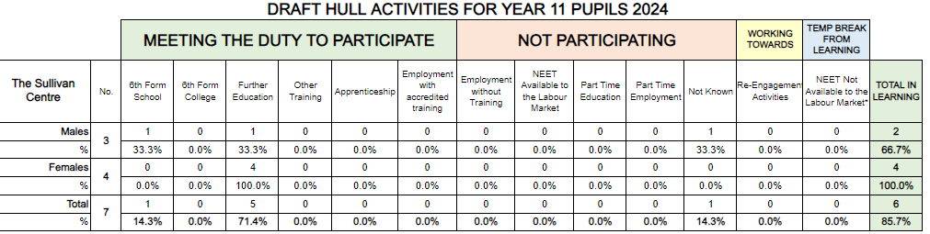

- Management of provider access requests
Procedure
A provider wishing to request access should contact Kerry Williams kerry.williams@vennacademy.org

- Opportunities for access
The school offers the six provider encounters required by law (marked in bold text) and a number of additional events, integrated into the school careers programme. We will offer providers an opportunity to come into school to speak to pupils or their parents or carers.

Please speak to our Careers Leader to identify the most suitable opportunity for you.

 | Autumn Term | Spring Term | Summer Term
Year 6 | Students will explore their interests, values, identity and personality.  Awareness that physical and mental wellbeing are important  Awareness of range of jobs available
Year 7 | Students will understand the role of the Careers Advisor  Enterprise projects completed each Term.  Students will explore their interests, values, identity and personality linking with a range of possibilities for themselves in their career.  Awareness that physical and mental wellbeing are important  Awareness that ‘career’ describes their journey through life
Year 8 | Enterprise projects completed each Term.  Students will explore their interests, values, identity and personality linking with a range of possibilities for themselves in their career.  Awareness that physical and mental wellbeing are important  Awareness of the concept of work-life balance  Students will identify a role model and be aware of the value of leadership  Awareness of the range of ways that organisations undertake recruitment and selection  Awareness that learning, skills and qualifications are important for careers/future  Awareness of post 16/18 routes available
Year 9 | Students will understand the meaning of ‘informed decisions’  Enterprise projects completed each Term. | Students will make informed decisions when choosing GCSE options.  Enterprise projects completed each Term. | Students have an awareness of GCSE and BTECs.  Enterprise projects completed each Term.
Year 10 | Students will understand how top plan their career journey  Career focus in Tutor time/collective worship  Employability NCFE course delivered each week.  Enterprise projects completed each Term. | KS4 Careers event  Employability NCFE course delivered each week.  Enterprise projects completed each Term. | Students will have an awareness of the progression routes after year 11  Employability NCFE course delivered each week.  Enterprise projects completed each Term.
Year 11 | Careers Advisor in school regularly and working alongside  Enterprise projects completed each Term.  Visits to FE settings  Employability NCFE course delivered each week.  Pupils will begin to develop some awareness of skills employers are looking for  All pupils take part in work experience | KS4 Careers event  Careers Advisor in school regularly and working alongside you person and family.  Employability NCFE course delivered each week.  Feel more prepared to ready for the world of work/further education/sixth form  Enterprise projects completed each Term. | Employability NCFE course delivered each week.  Enterprise projects completed each Term.
Post 16 | Post 16 event with pupils and families  Enterprise projects completed each Term. | Enterprise projects completed each Term.  Higher education lessons delivered on a personalised provision  Take part in volunteering and work experience. | Enterprise projects completed each Term.

Please speak to our Careers Leader to identify the most suitable opportunity for you.

- Premises and facilities
The school will make the classrooms or private meeting rooms available for discussions between the provider and students, as appropriate to the activity. The school will also make available AV and other specialist equipment to support provider presentations. This will all be discussed and agreed in advance of the visit with the Careers Leader or a member of their team.
Providers are welcome to leave a copy of their prospectus or other relevant course literature at the school office. This will then be shared with the students in their tutor groups.

